**Designing The ViewAllScoreFrame**

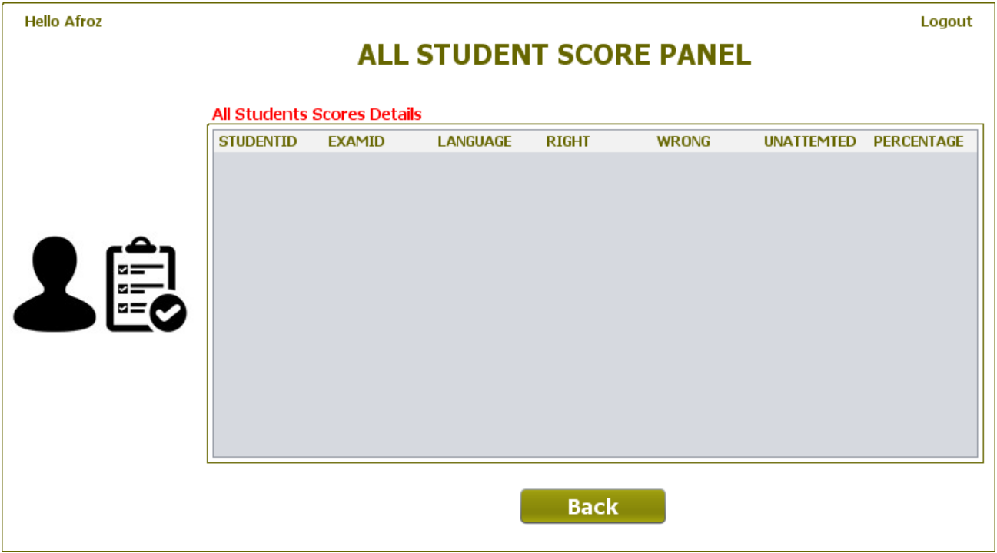

**STEPS TO BE DONE IN** **ViewAllScoreFrame**

In the **ViewAllScoreFrame** we need to do following steps:

1. Display **username** on the top left

2. Allow the user to **logout**

3. Handle the constructor so that it loads complete details of all the students who have appeared for test from the database. To do this we need to call the method **getAllData( )** of the class **PerformanceDAO**.

4. Handle the "**Back**" Button

**THE TABLES USED IN ViewAllScoreFrame**

|  |  |  |
| --- | --- | --- |
| **Column Name** | **Data Type** | **Description** |
| **USERID** | **Varchar2(10)** | **Contains Admin Provided User ID** |
| **EXAMID** | **Varchar2(10)** | **Contains id of the paper** |
| **RIGHT** | **Number(4)** | **Number of correct answers** |
| **WRONG** | **Number(4)** | **Number of wrong answers** |
| **UNATTEMPTED** | **Number(5)** | **Number of unattempted questions** |
| **PER** | **Number(5,2)** | **Percentage obtained** |
| **LANGUAGE** | **Varchar2(10)** | **Programming language name** |

**THE POJO CLASSES USED IN ViewAllScoreFrame**

1. The **Performance** POJO

**THE DAO CLASSES USED IN ViewAllScoreFrame**

1. The **PerformanceDAO**

**HOW TO LOAD AND SHOW ALL STUDENT EXAM DETAILS:**

To do this we need to create a method called **getAllData( )** in the class **PerformanceDAO**. This method should fetch and return details all the students from the table **PERFORMANCE.** This return value is a list of **Performance** POJO objects . So the prototype of this method will be:

***public static ArrayList<Performance> getAllData()throws SQLException***

**DISPLAYING STUDENT DETAILS IN JTABLE:**

To display details of all the students we have to use another UI control called **JTable**. The **JTable** control allows us to display multiple rows of data. So we need to create a method called **showDataInTable()** in the **ViewAllScoreFrame** which does the following:

**a. Calls the method getAllData( ) of the class PerformanceDAO.**

**b. If no id is returned , it displays the message "No student has yet appeared for the exam"**

**c. Otherwise it iterates over the student list and displays it in the JTable**

**d. It also handles SQLException which the method getAllStudentId( ) of the class PerformanceDAO can throw**.

**HANDLING THE CONSTRUCTOR:**

From the body of constructor we would call the above method so as to show the students details as s soon as the frame opens

**WRITING THE CODE FOR BUTTON Button.png IN ViewAllScoresFrame**